|  |  |  |  |  |  |
| --- | --- | --- | --- | --- | --- |
| Date | 24-Nov-22 | | | Tester Name | Mohammad Yusuf |
| Environment | Penfax - Test | | | Login used |  |
| Operating System | Select OS | Version: | Update: | | |
| Software Used | Select Software | Version: | Update: | | |
| Select Software | Version: | Update: | | |
| Release version |  | | | | |
| Title | M17 Contributions & DCT | | | | |
| Test Type | Regression | | | | |
| Test Scenario | M17.01 Post SIN Contribution manually | | | | |
|  |  | | | | |
| Expected Results | Processed contributions should be shown under Payroll History and Contribution History.  Accounting should be verified in General Ledger. | | | | |
| Pass/Fail | Pass | | | JIRA# | N/A |

Describe your steps with screenshots:

1. Log into MEPP DCT and select the Employer from the dropdown.

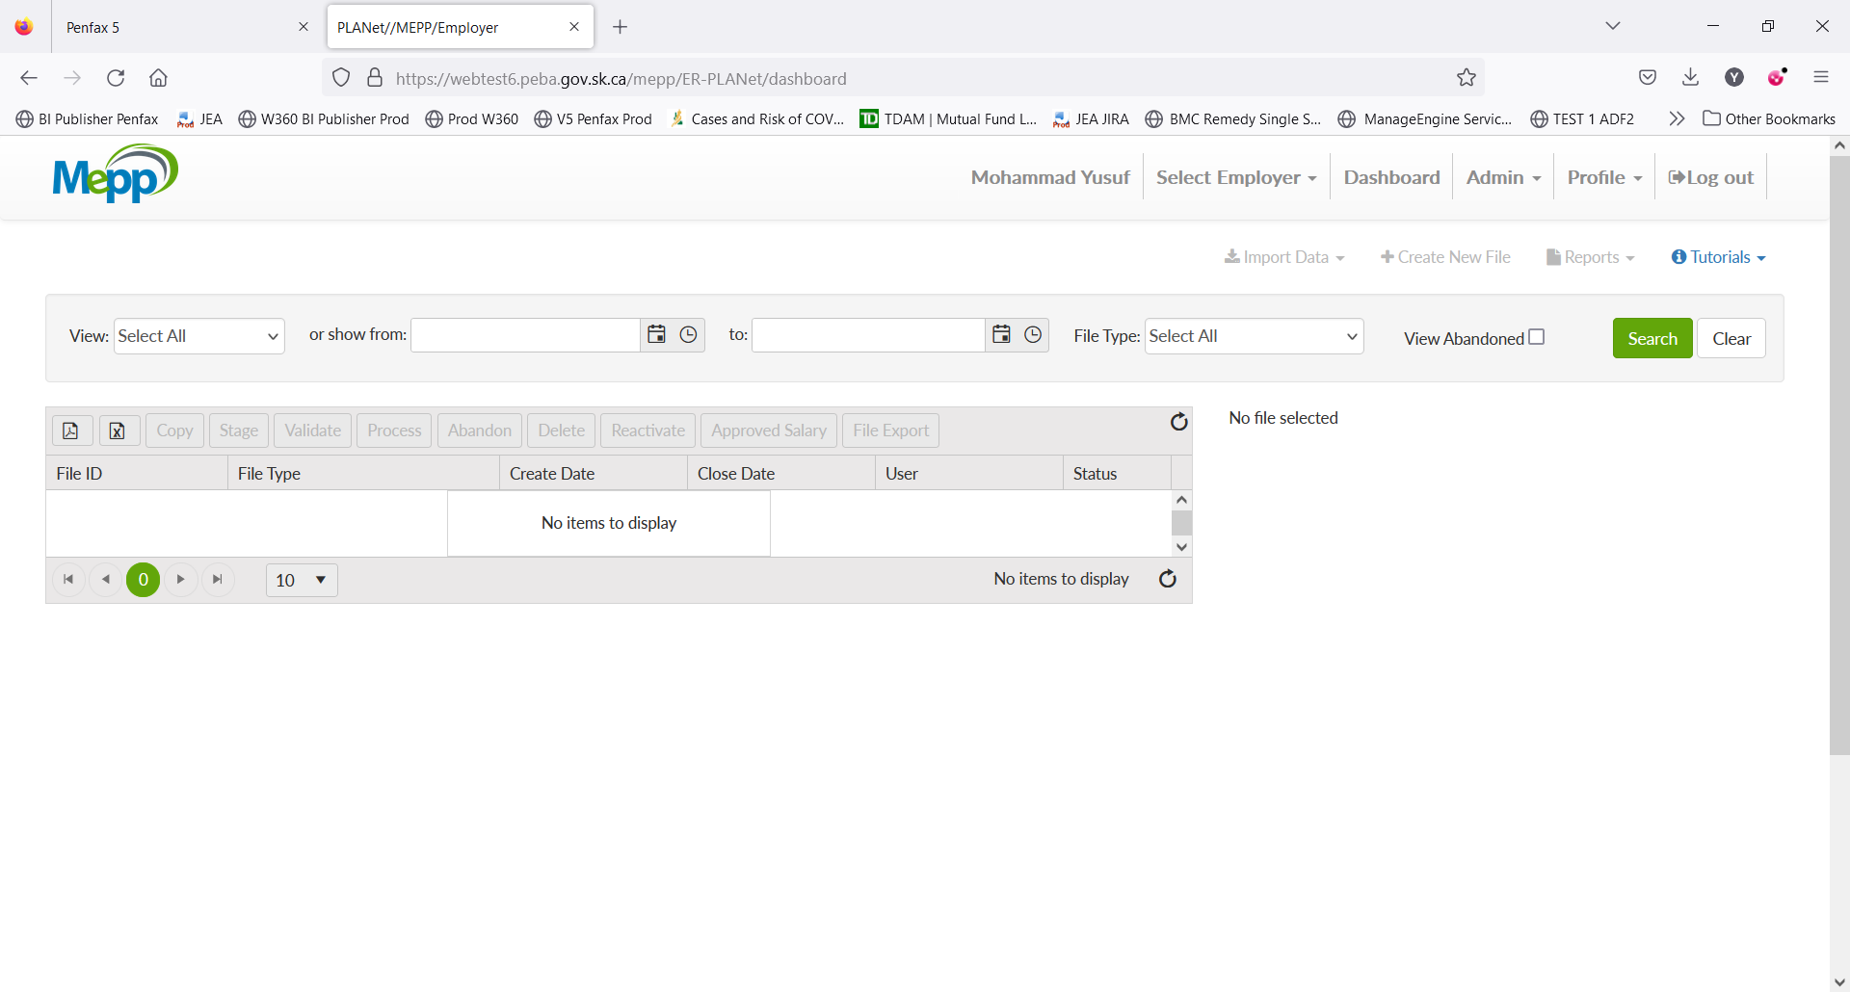

1. Click on Create New File.

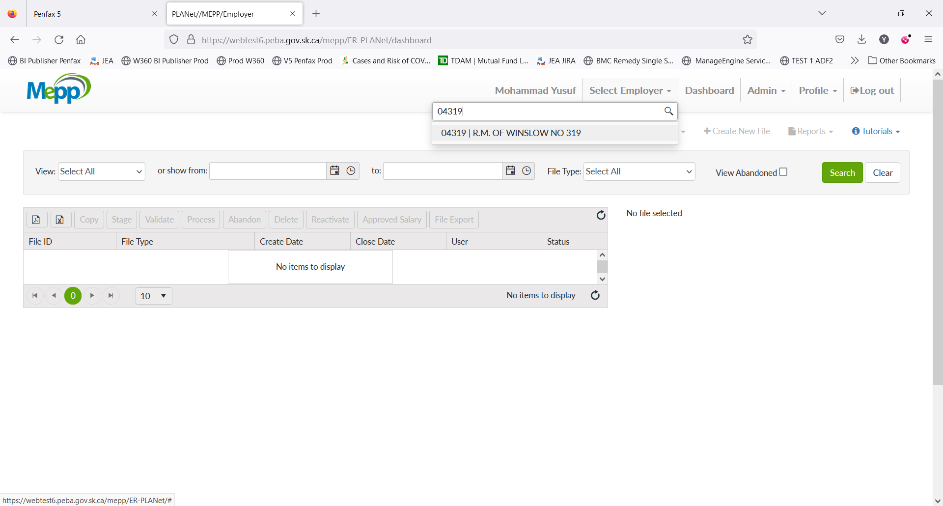

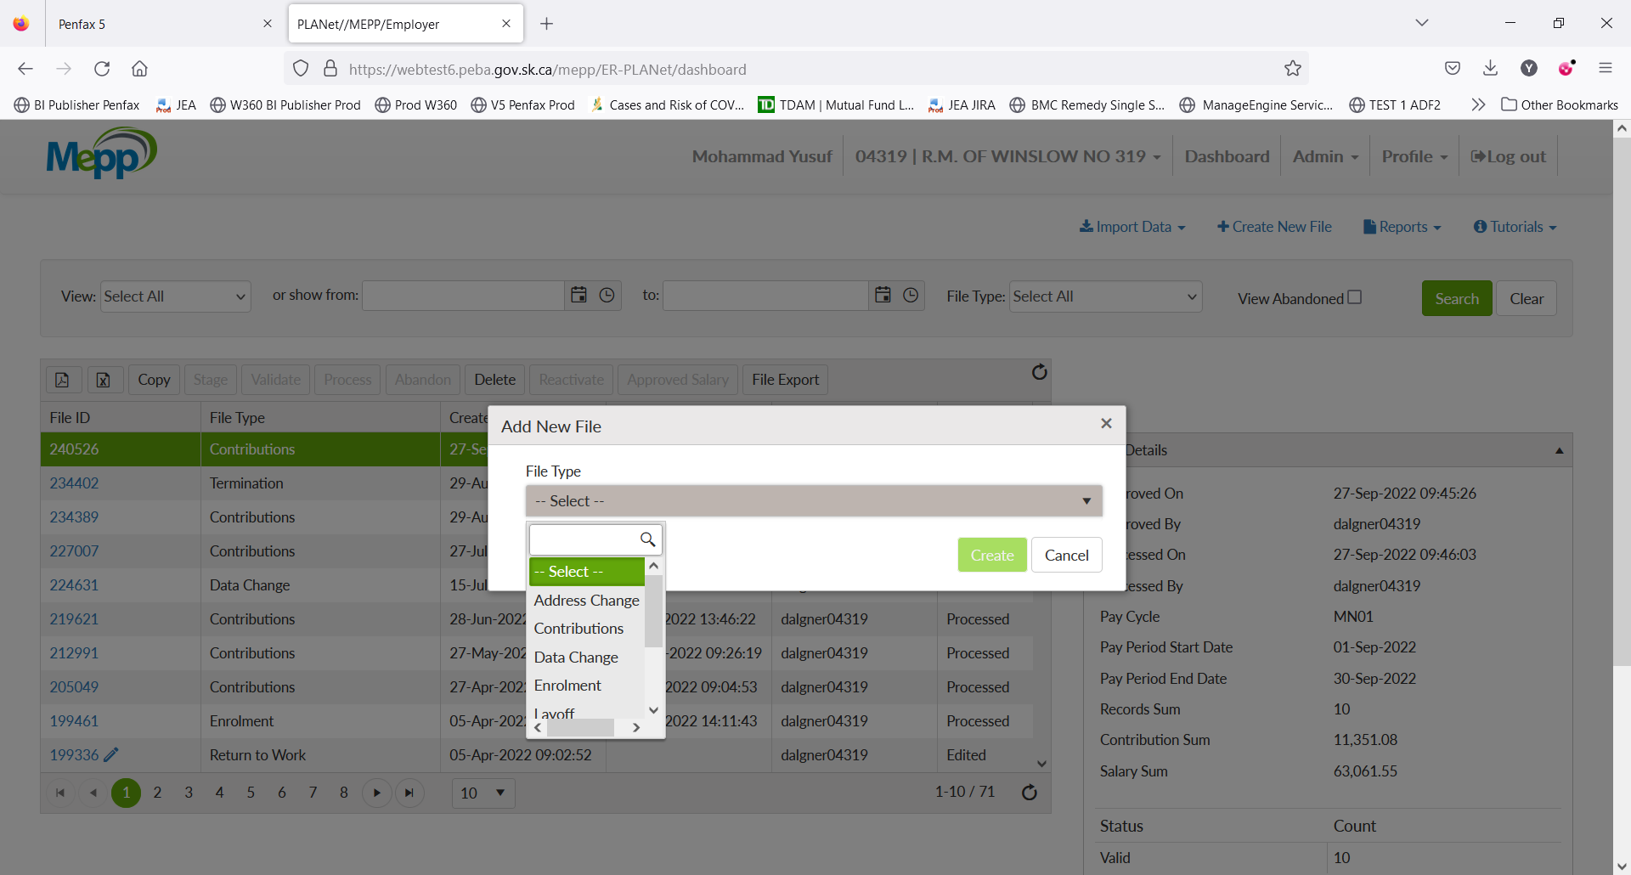

1. Select Contribution from the dropdown.

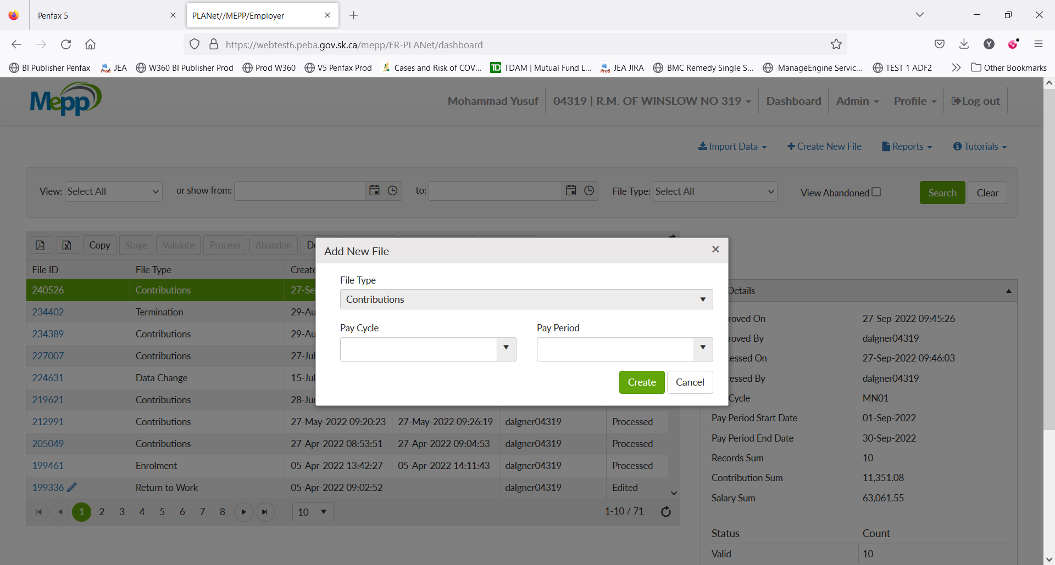

1. Input Pay Cycle and Pay Period and click on Create.

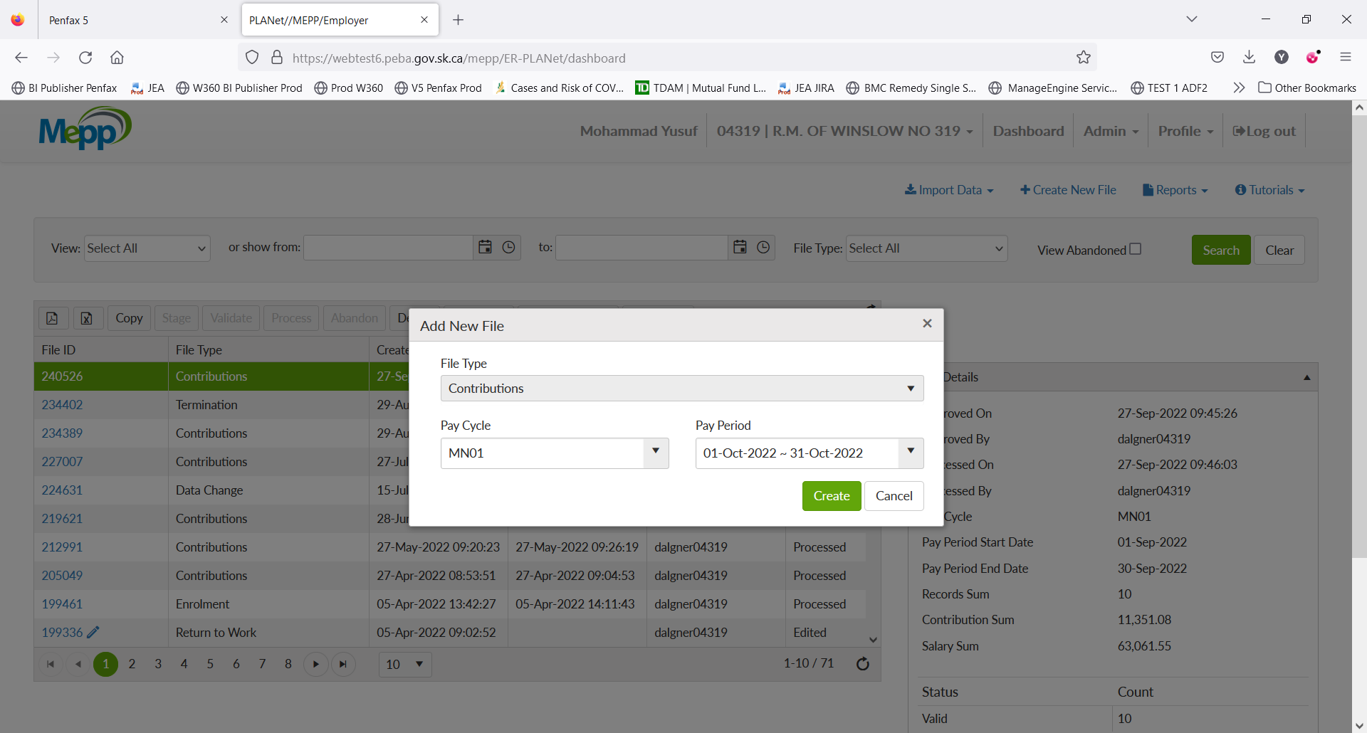

1. Click on File ID.

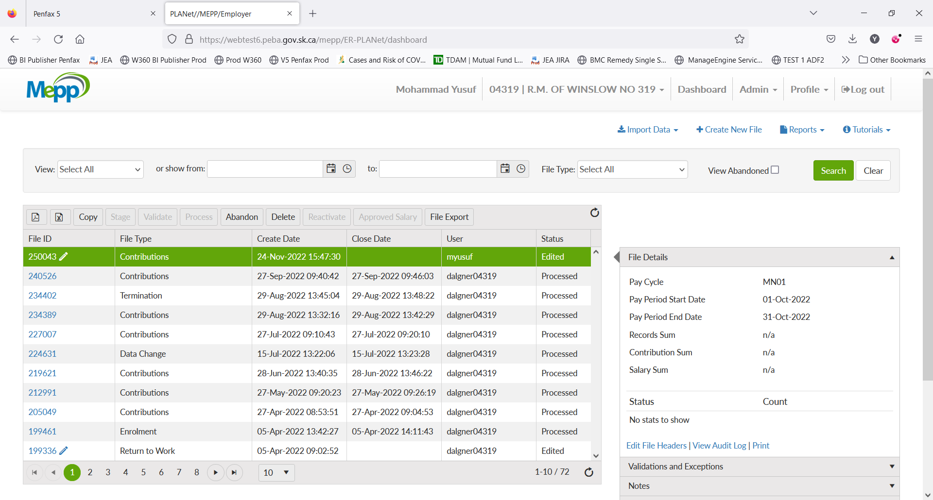

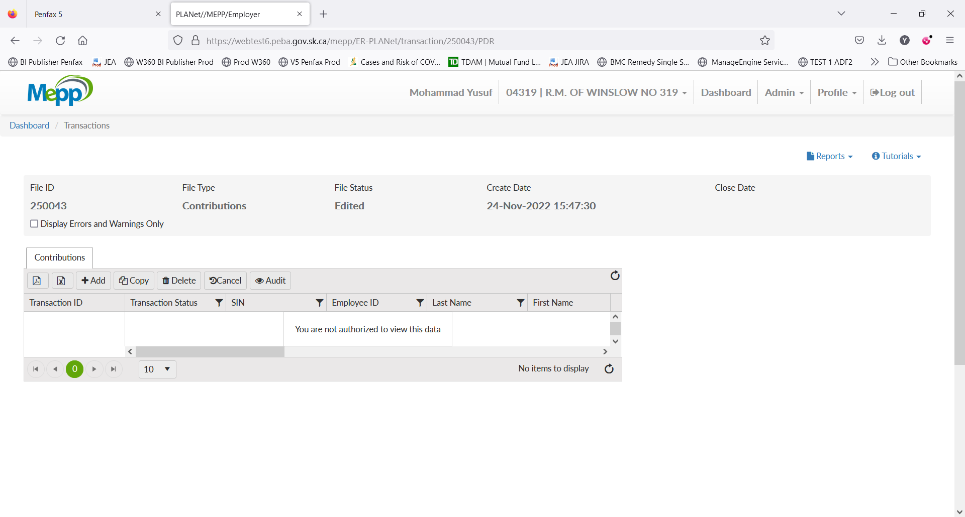

1. Click on Add to add the transactions.
2. Input all the required details and Save.

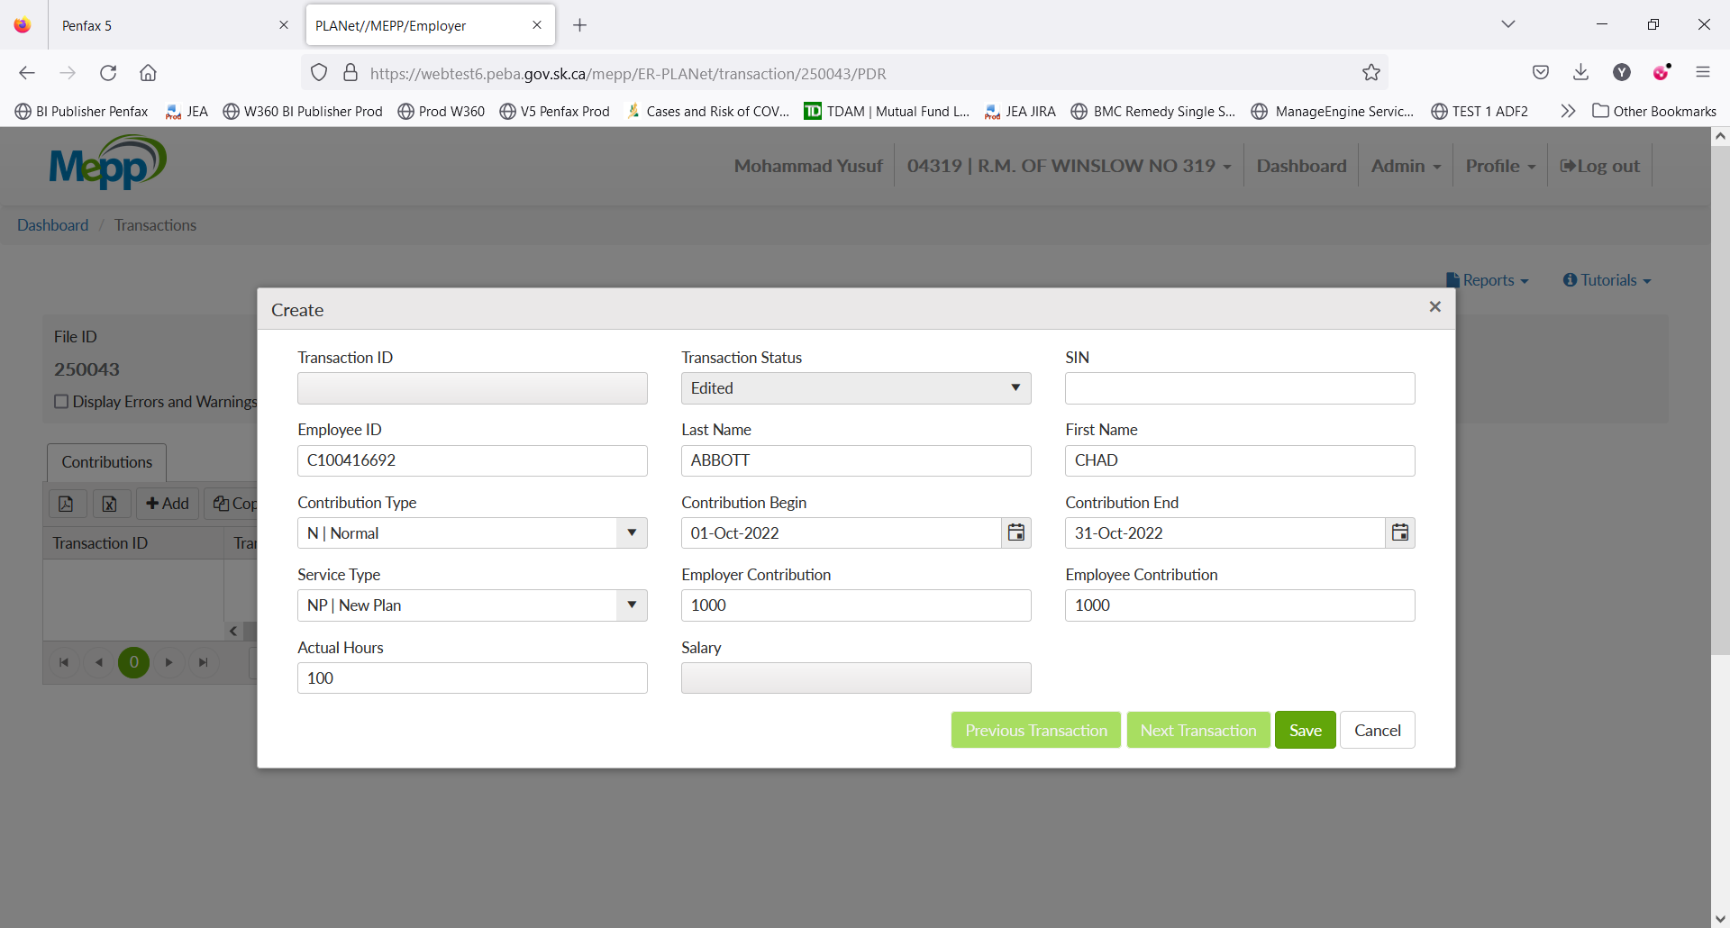

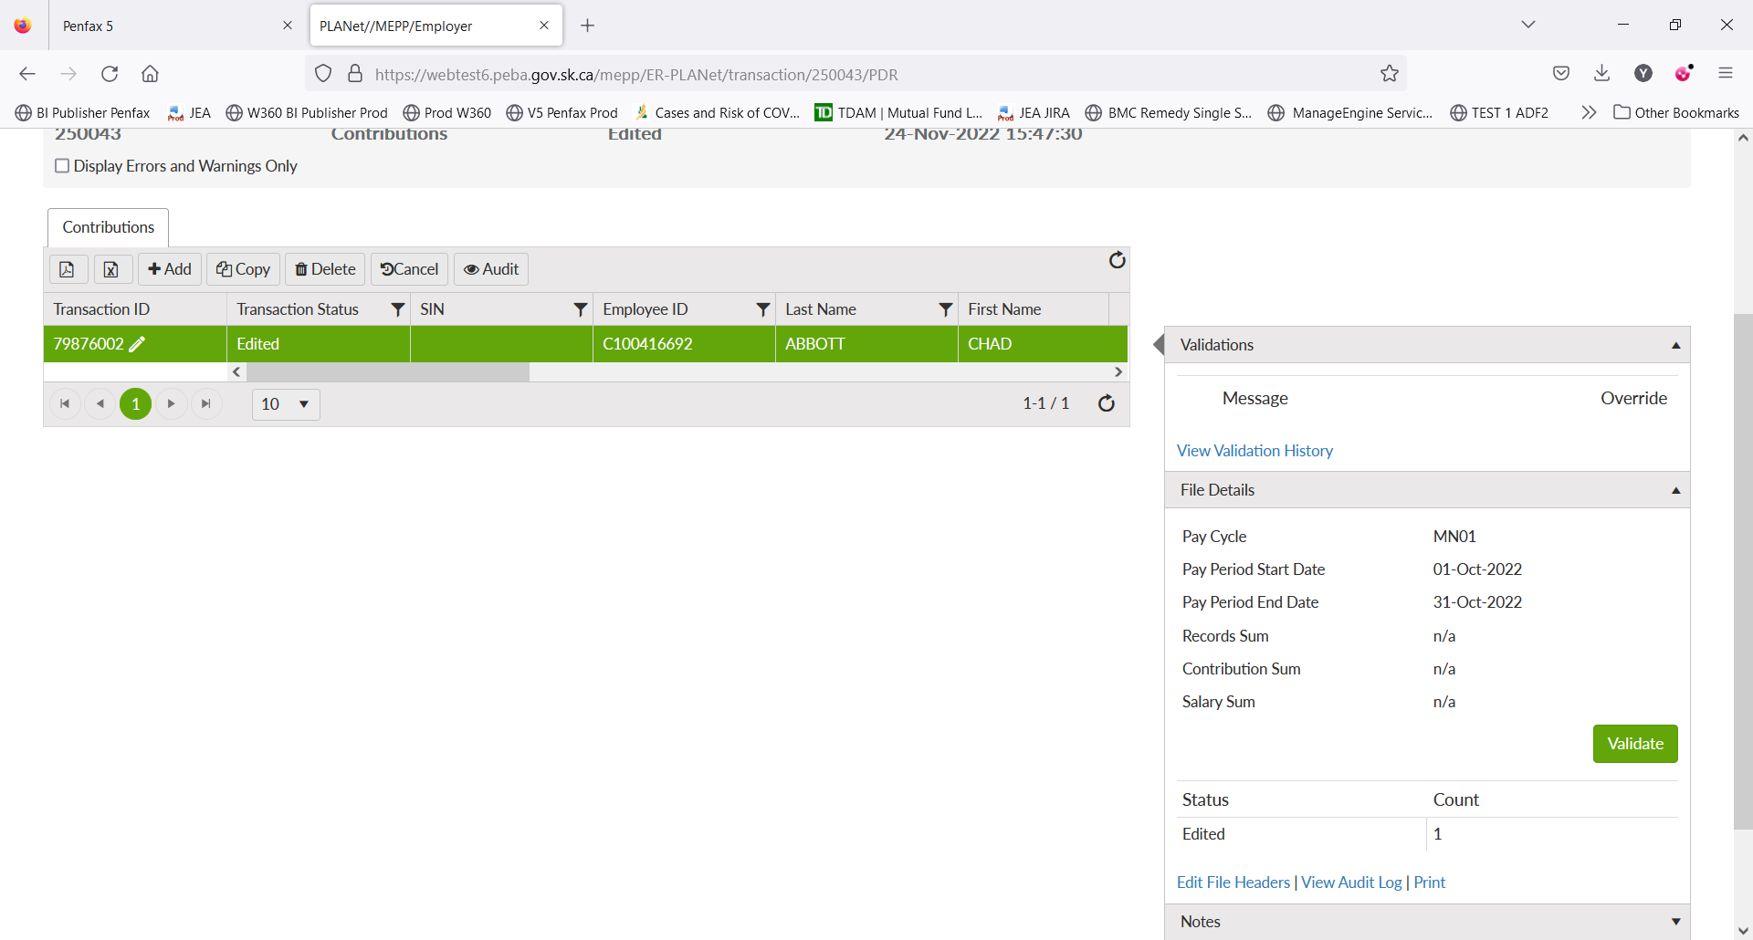

1. Under File Details, click on Validate.
2. Now, all the details available under File Details. Click on Approve Salary.

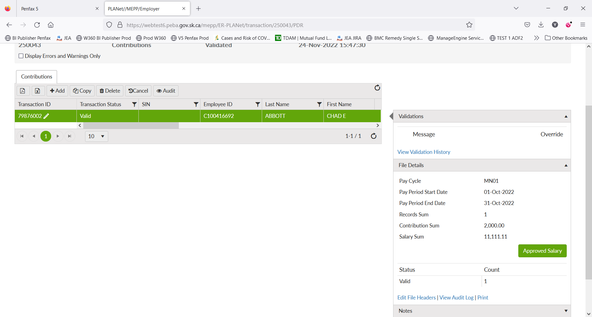

1. Click on Process.

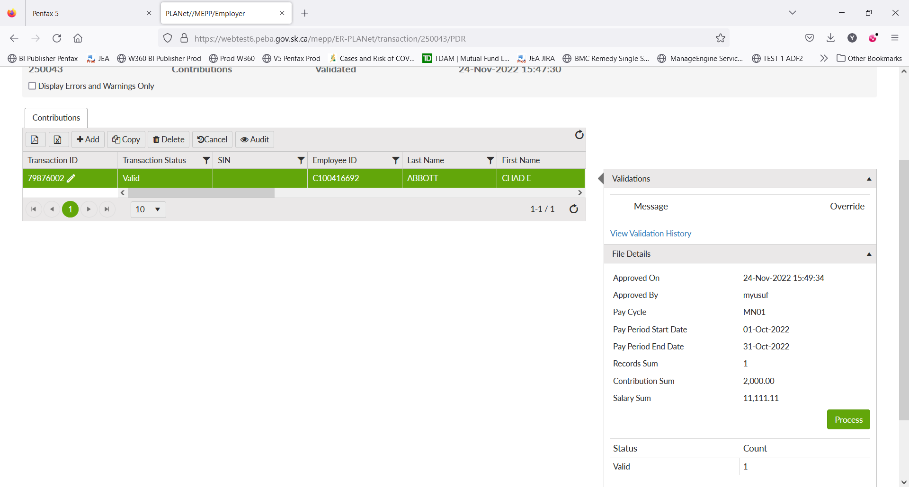

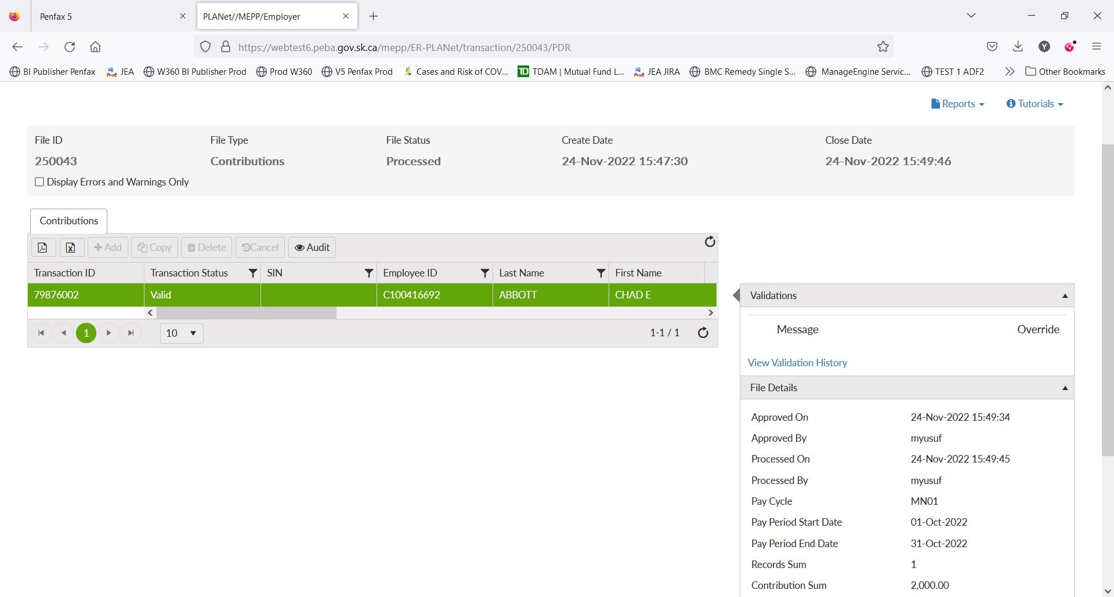

1. File is processed now.
2. Log into Penfax. Click on Batches -> Data Posting Batches. Search with the employer and then click on the batch id you just processed in DCT.

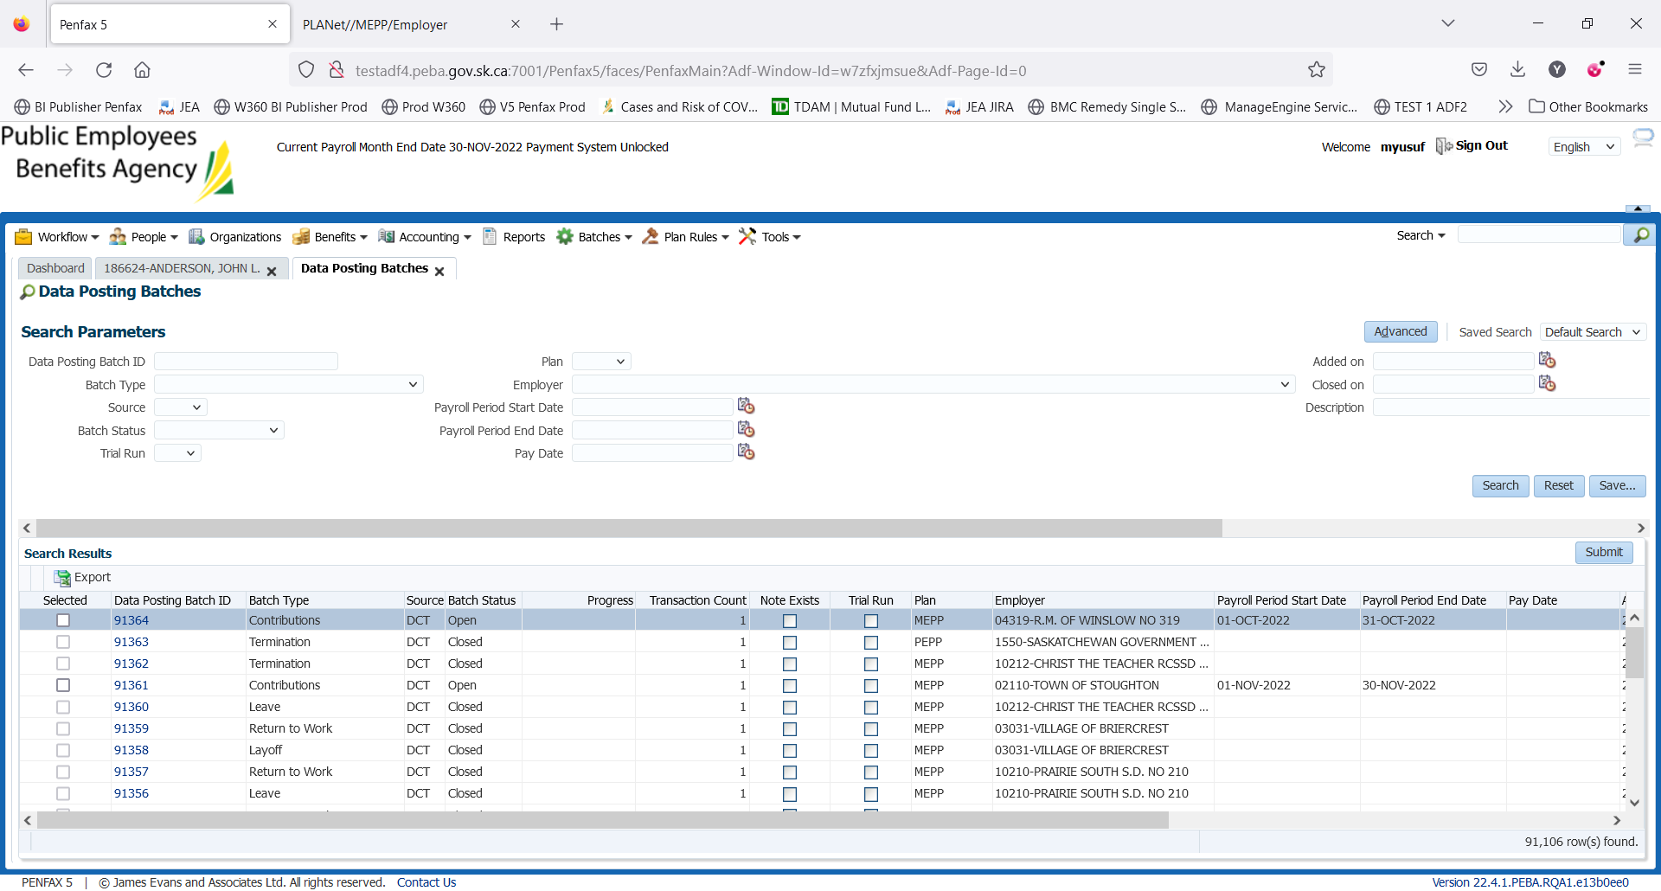

1. Go to Pending Tab. Verify the details in header. 2 validation errors are for remittance.

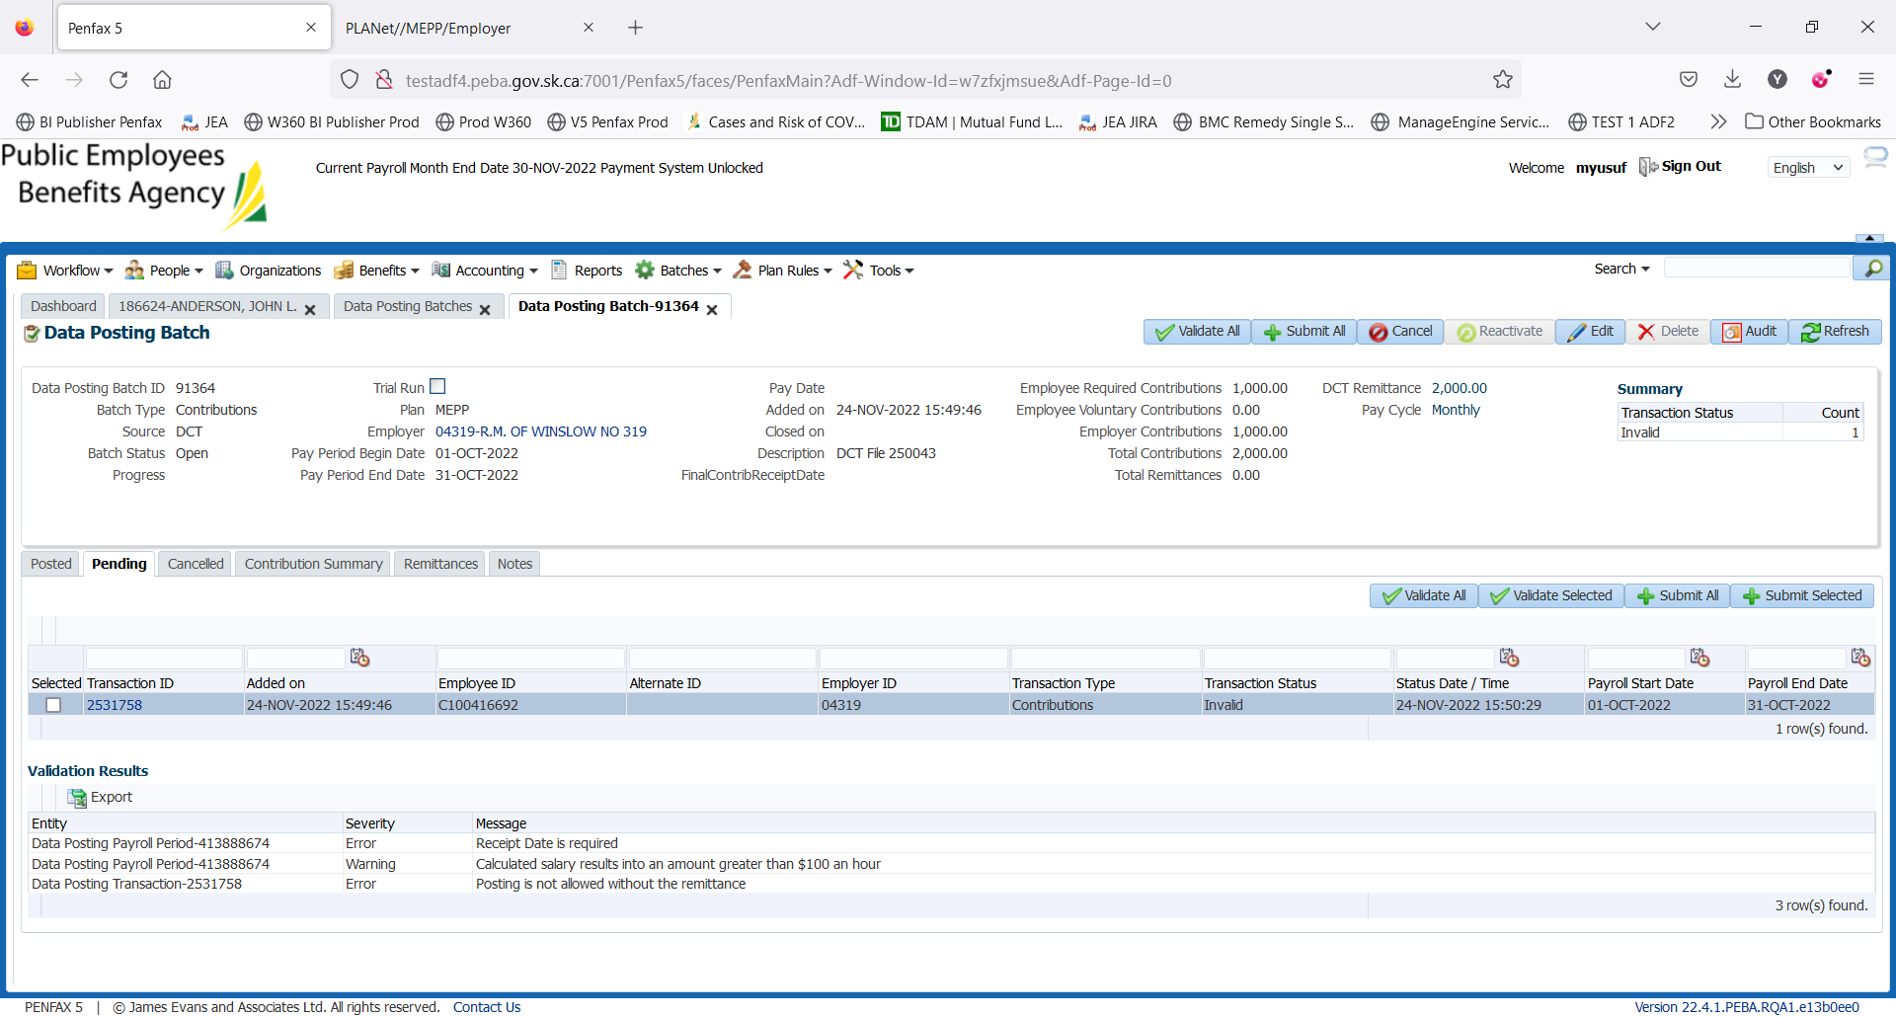

1. Go to Remittances tab, click Add and link the remittance.

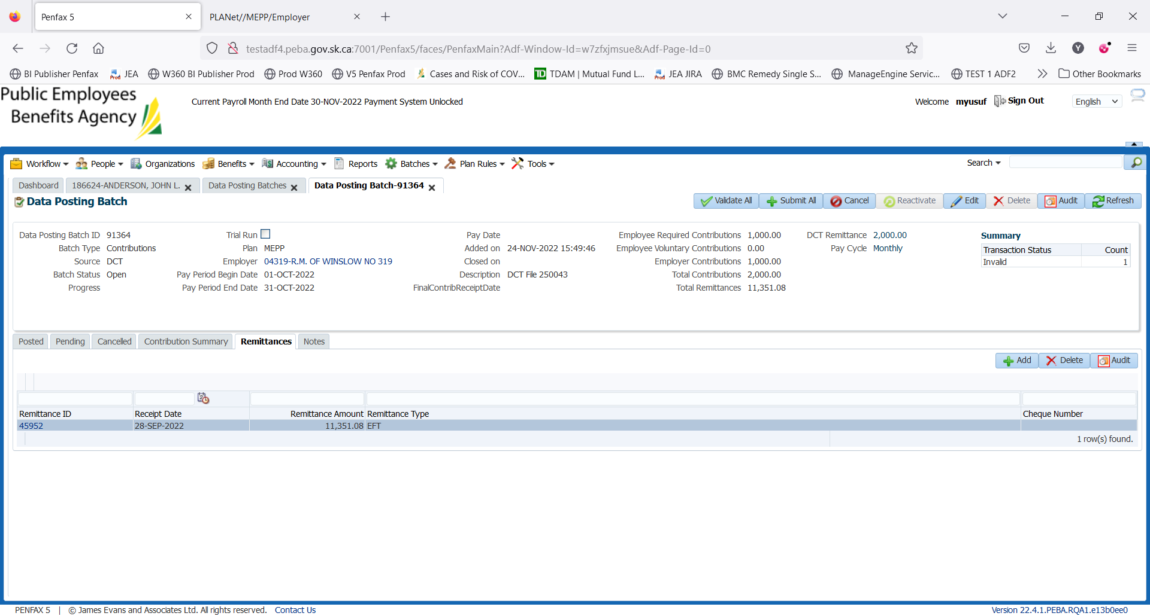

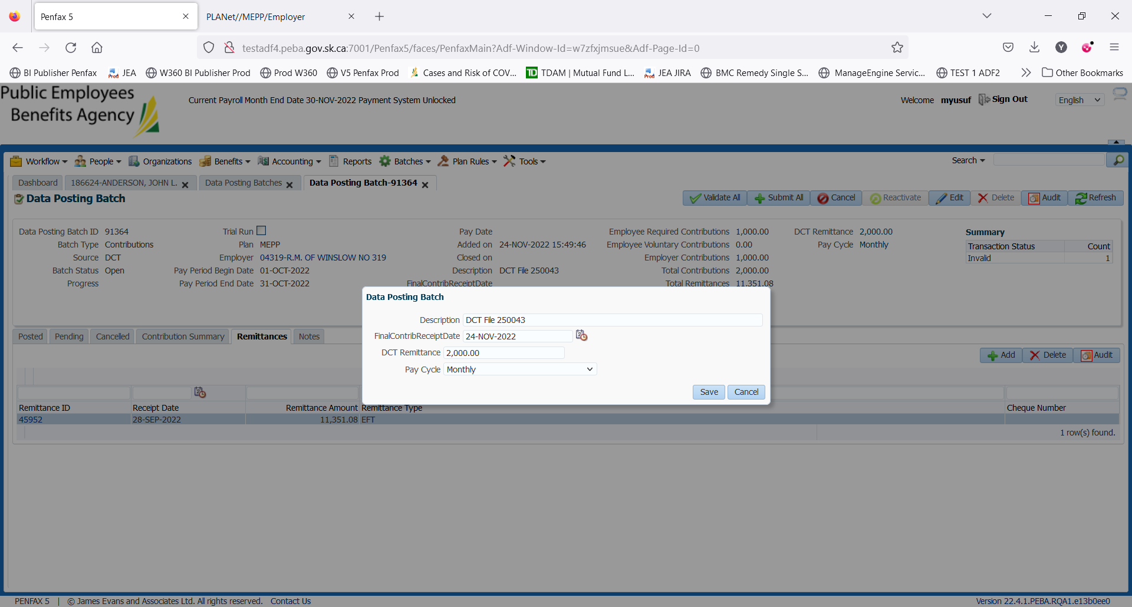

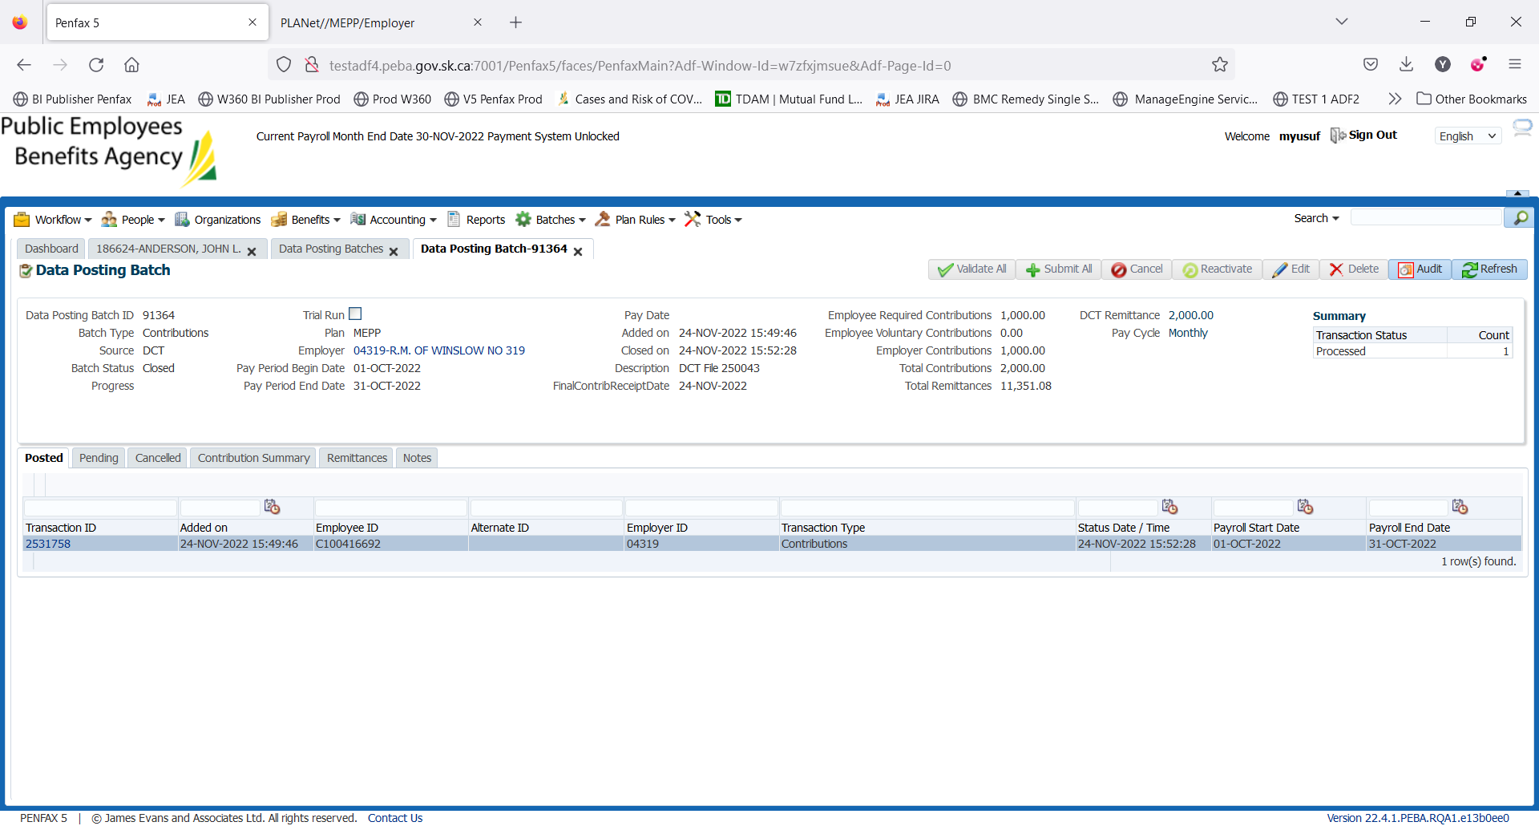

1. Go to Pending tab. Click on Validate All.
2. Click on Submit All.
3. Go to Posted tab. Data Posting Transactions are processed so Batch is now closed and the contributions are posted to member’s account.

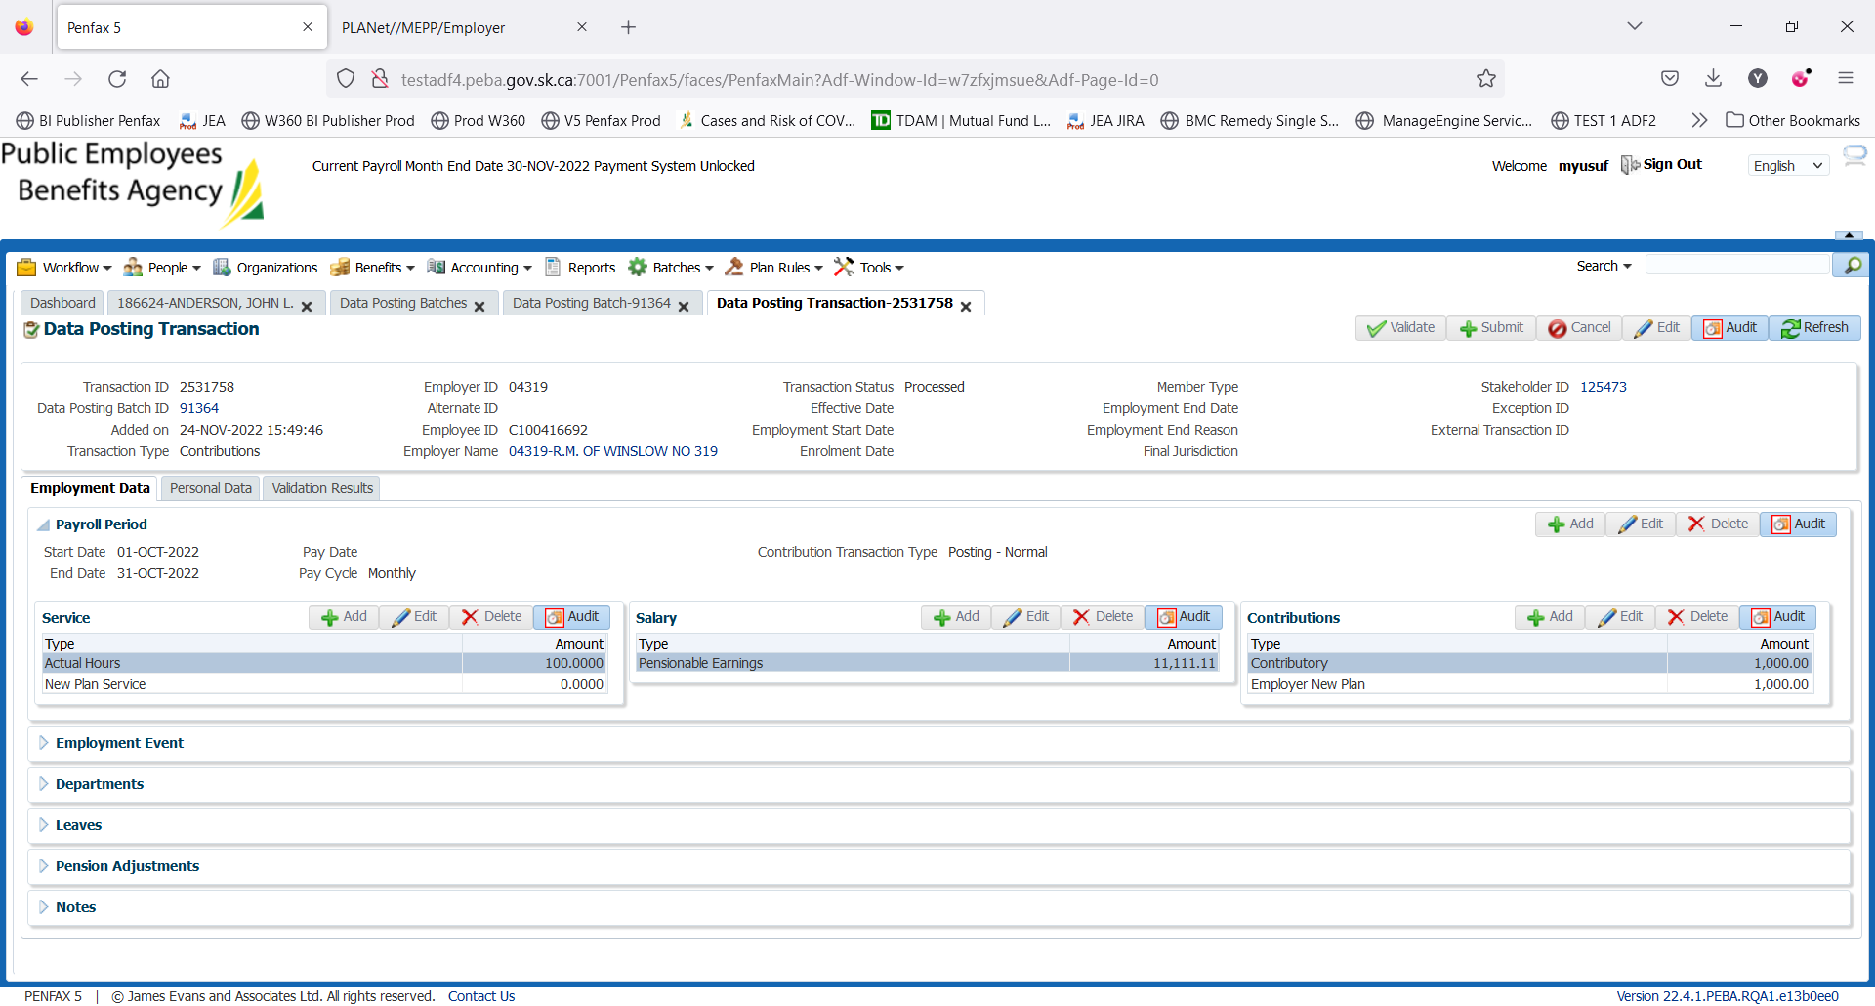

1. Bring up your member and go to Payroll History.

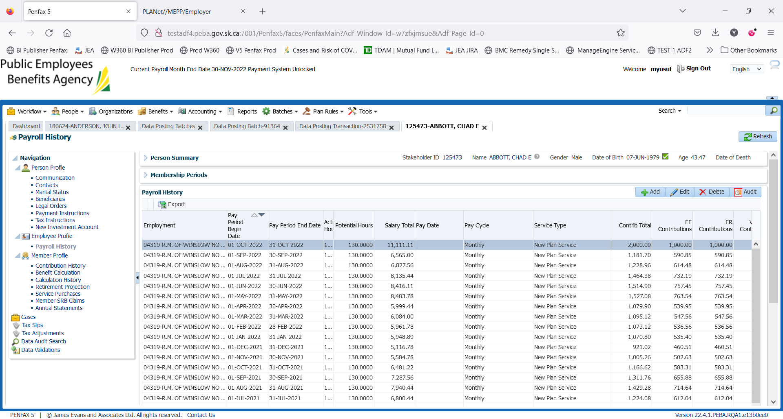

1. Go to Contribution History.

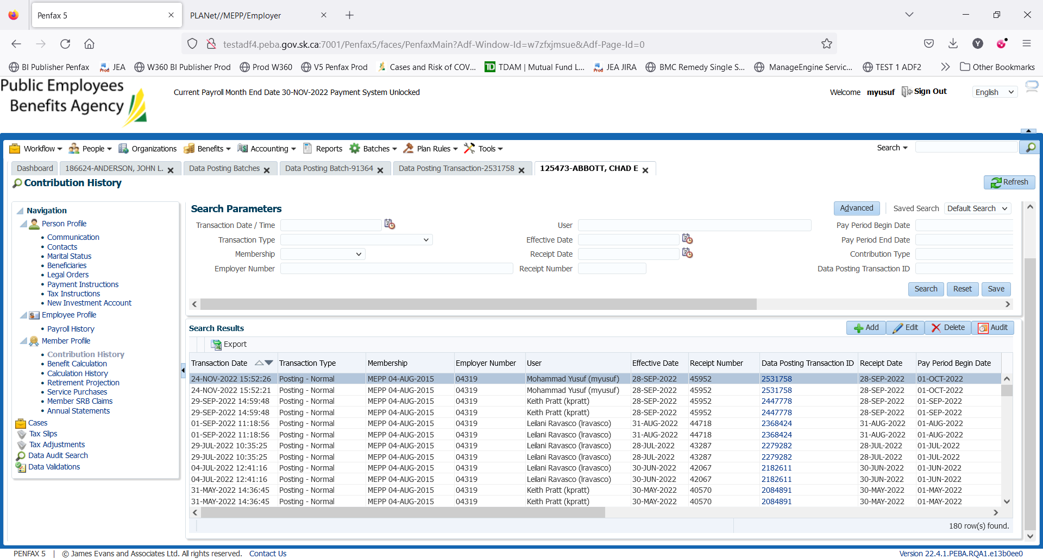

1. Verify Journal Entry in Data Posting Batch.

Go to Contribution Summary tab in Data Posting Batch.

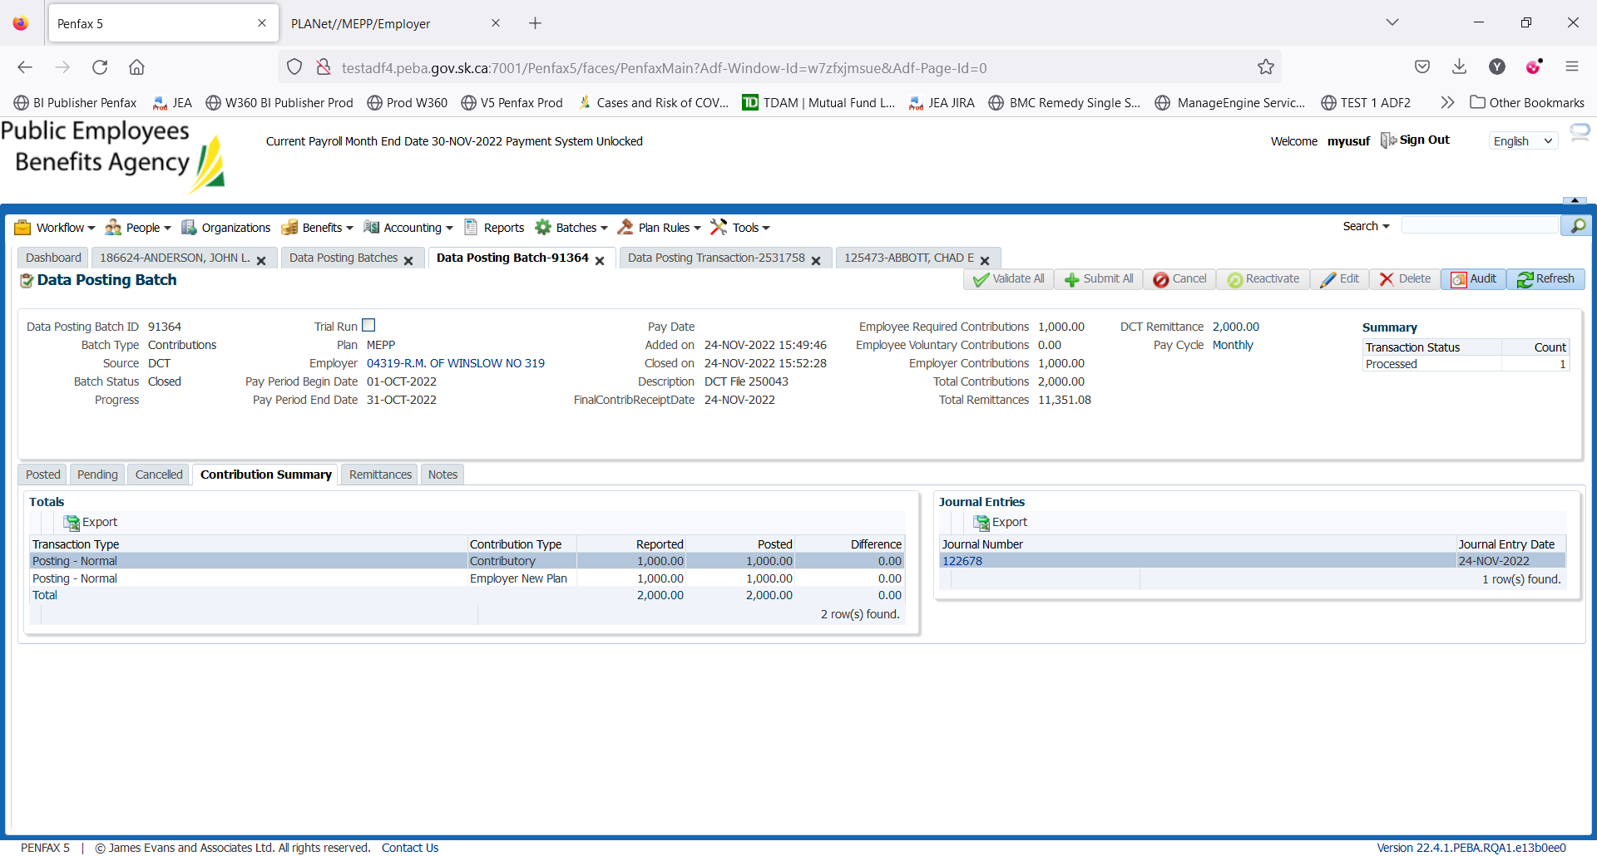

Click on Journal Number. Verify the details as per your posting.

